**HUMAN COMPUTER INTERACTION**

**ASSIGNMENT NO. 3**

**Group Assignment**

**BSE 6B 04 Marks**

**Muaz Shahzad**

**Talha Zafar**

**Awais Asad**

**Hassan Akhtar**

NEED FINDING [CLO2]

You are required to develop a prototype for a mobile-based/web-based application from the design project ideas shared with you on LMS. For that purpose, you have to focus on user needs and goals first.

Need finding involves Observations and Interviews to find out the needs of users. After selection of a project design from the shared list, select individuals who you can interview (2 people per project member) to find out the opportunities for the app to solve existing problems. Interviews can be remote.

After reviewing the findings of user needs, submit a list of user needs for your potential app which may be incorporated in the app design.

Sketch 2 story board and upload their images showing the goals achieved using your application.

**Interviews**

**Muaz**

**Q1:** **What are the main advantages of using a restaurant management system for restaurant owners?**

A restaurant management system offers several benefits for restaurant owners, such as streamlined operations, improved efficiency, accurate inventory management, enhanced customer service, and real-time reporting for better decision-making.

**Q2:** **How can a restaurant management system help in optimizing the ordering and inventory process?**

A restaurant management system can automate the ordering process, ensuring accurate and timely procurement of ingredients and supplies. It can also provide real-time inventory tracking, minimizing waste, reducing stockouts, and helping in better cost control.

**Talha**

**Q1: How can a restaurant management system enhance the customer dining experience?**

A restaurant management system can facilitate smooth table reservations, efficient order taking, and faster service. It can also integrate with loyalty programs and enable personalized customer interactions, enhancing overall customer satisfaction and loyalty.

**Q2: What features of a restaurant management system are most beneficial for restaurant staff?**

Restaurant staff can benefit from features such as streamlined order management, kitchen display systems for efficient food preparation, table management for optimal seating arrangements, and real-time communication tools to improve collaboration and coordination among staff members.

**Awais**

**Q1: What are the key features of a restaurant management system that contribute to effective cost management?**

A restaurant management system can provide tools for monitoring and analyzing sales data, tracking inventory and ingredient costs, managing labor expenses, and generating reports for better cost control and decision-making.

**Q2: How can a restaurant management system help in streamlining the billing and payment process?**

A restaurant management system can automate the billing process, generate accurate and detailed bills, and integrate with various payment methods, such as cash, credit cards, or mobile payments, making the payment process more efficient and convenient for both customers and staff.

**Hassan**

**Q1: How does a restaurant management system help in generating insightful reports for business analysis?**

A restaurant management system can generate reports on sales, revenue, inventory, customer behavior, and other key metrics. These reports provide valuable insights for analyzing performance, identifying trends, and making data-driven decisions to improve the restaurant's overall.

**Q2: How does the restaurant management system help with inventory management and cost control?**

The restaurant management system tracks inventory levels, monitors ingredient usage, and generates reports to identify trends and patterns. This helps in optimizing stock levels, reducing wastage, and controlling costs by providing insights into purchasing and pricing strategies.

**StoryBoard 1: Ordering**

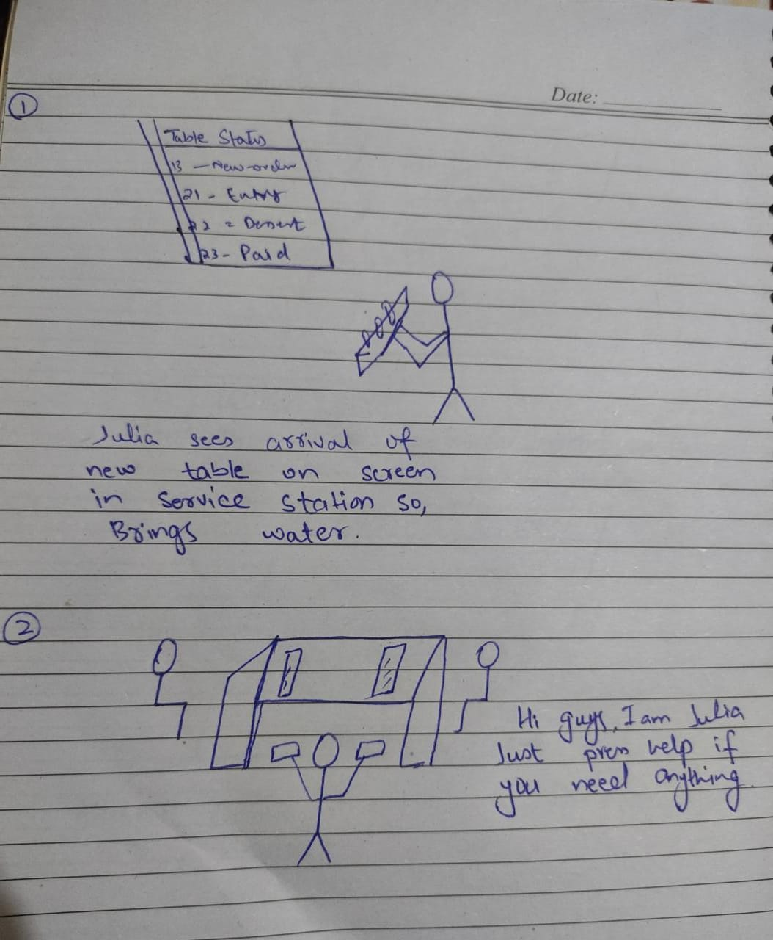

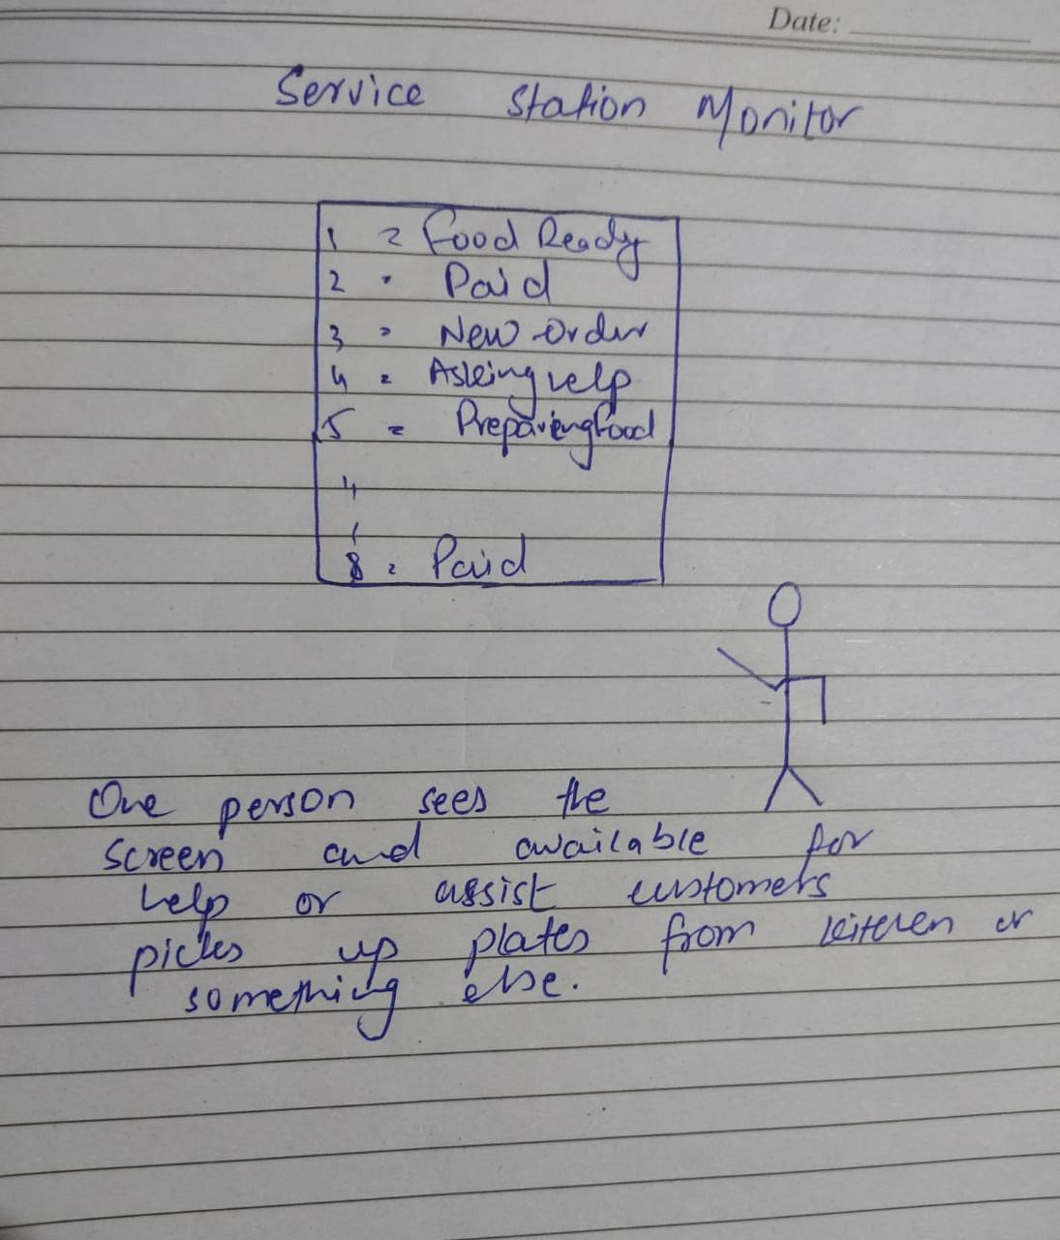

**Storyboard 2: Payment Process**

**Customer Table**

**Screen show the ordered items to customers on table.**

**A person clear the table pick up empty plates etc. After paid showed on service station screen.**

